Name _______________________________________ Period ______________ Mrs. Coates—Earth Science
Solar Energy Unit Tracking Sheet
Learning Target | Question Example | Date Target was Taught in Class
Solar energy is reflected, absorbed, or scattered by the atmosphere, oceans, and land | If there were more snow and ice on the Earth’s surface, would the surface absorb more or less solar energy? | January 3/4
The greenhouse effect changes solar energy into heat energy | How does the greenhouse effect change Earth’s temperature? | January 5/8
The tilt of Earth’s axis causes uneven heating of the surface and atmosphere | Which location on Earth gets the most DIRECT radiation? | January 9/10
Uneven heating of the atmosphere creates the Coriolis effect | What is the pattern of movement of the trade winds? | January 11/12
Ozone in the stratosphere is good, while ozone in the troposphere is bad | What health problem is associated with the ozone hole? | January 16/17

 | Pre-Test | Solar Energy | Greenhouse Effect | Uneven Heating | Coriolis Effect | Ozone | Post Test
4
(90-100%)
3
(80-89%)
2
(70-79%)
1
(0-69%)
My Progress
Test: January 22/23
AH-HA!

How does energy from sun affect the atmosphere?

Date | Question | Answer
Science Starter Sheet
Science Starter Sheet
Date | Question | Answer

Solar Energy—Notes
Sunlight travels to earth as ______________________________________________.
The Earth deals with three types of heat:
- Radiation:
- Convection:
- Conduction:
We can measure solar radiation in ______________________ (W/m²). Earth receives about _________ W/m² of energy.
Reflection:
What it is: | Drawing:

Absorption:
What it is: | Drawing:

Scattering:
What it is: | Drawing:

 | Reflection? | Absorption? | Scattering?
Role of Atmosphere
Role of Oceans
Role of Dry Land
Role of Ice and Glaciers
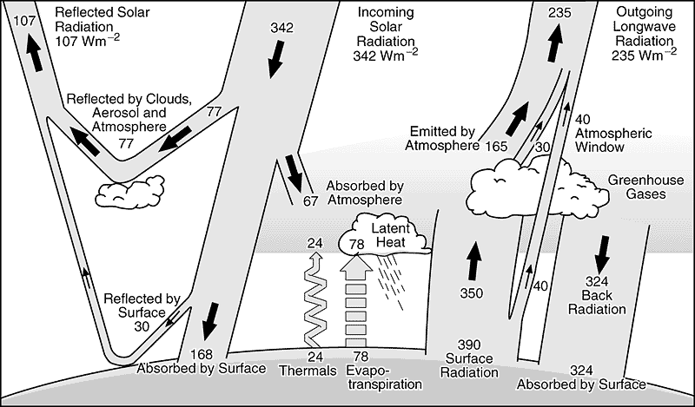
Label all of the REFLECTED energy with the color blue. Label all of the ABSORBED energy with the color red.
Source: Kiehl and Trenberth, 1997
Label the INCOMING energy with the color yellow. Label all OUTGOING energy with the color brown.

Solar Energy Math
Analyze the graph below and answer the following questions:
- What is the total amount of incoming solar radiation?
- What percentage of solar radiation is absorbed by Earth’s surface?
- What percentage of solar radiation is reflected by clouds and atmosphere?
- What percentage of solar radiation is absorbed by the atmosphere?
- What is the total amount of outgoing long wave radiation leaving Earth’s atmosphere?
- Use a blue crayon to circle the areas where the surface is ABSORBING energy (there are two).
- Use a red crayon to circle the areas where energy is LEAVING the surface (there are three).
- Looking only at the surface of the earth, what is the total amount of energy being absorbed by the surface?
- Looking only at the surface of the earth, what is the total amount of energy leaving the surface?
- Is the amount of energy being absorbed equal to, less than, or more than the amount of energy leaving?
- Explain why your answer for number 10 is important:
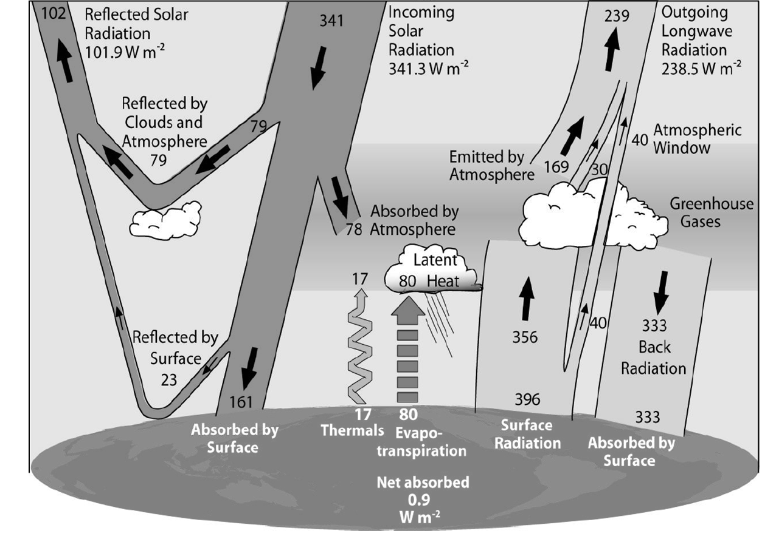
S’Mores STEM Challenge
The greenhouse effect is the process that traps Earth’s heat and keeps our planet warm. Today we are going to build models that uses this concept, and at the end of the challenge is a delicious treat! Your challenge today is to build a solar oven that can make a S’More. Your budget is $50 and you can choose materials as long as they fit this budget.
A Picture of Our Design: | Materials We Chose to Use:  Material: Cost:  Material: Cost:  Material: Cost:  Material: Cost:  Material: Cost:  Material: Cost:  TOTAL COST:
Description of How We Built Our Solar Oven (include the dimensions of your model):

Temperature Record
0 minutes | 20 minutes
5 minutes | 25 minutes
10 minutes | 30 minutes
15 minutes | 35 minutes
Analysis

What Worked: | What Didn’t Work:

Part 2:
Go to www.phet.colorado.edu/en/simulation/greenhouse. Run the “Greenhouse Effect” (first tab at the top of the JAVA page) and change the “Atmosphere During…” option. Observe any changes to the thermometer as you change the atmosphere. Continue changing the simulation and making observations, then answer the analysis questions below.
- How is the temperature TODAY different than during 1750?
- How is the amount of CO₂ in the atmosphere TODAY different than during the ICE AGE?
- Under “Greenhouse Gas Concentration,” what happens when you slide the scale so there is “Lots”?
- What happens when there is “None” (greenhouse gas concentration)?
- How is the simulation on the screen similar to your solar oven? (What part of your solar oven represented the atmosphere and what part represented the land?)

- How is the simulation on the screen different from your solar oven?
- Why are scientists concerned that the level of CO₂ in the atmosphere is continuing to rise?
Now click “Photon Absorption” at the top of the screen. Experiment with different atmospheric gases.
- Which gases absorb infrared photons (heat)?
- Which gases absorb visible photons (light)?
- Now “Build an Atmosphere” to compare Earth’s atmosphere to Mars’ (these models are not to scale!):
Earth’s Atmosphere:  Fifteen N₂, four O₂, two H₂O, two CO₂ | Mar’s Atmosphere:  one CO₂ molecule, one N₂ molecule
Observations: | Observations:
Direct and Indirect Radiation Lab
Background Information:
A
Using your protractor, determine the angle at which the sun’s radiation strikes the earth at the latitudes indicated by letters A, B and C. Write the angle next to the letter. What are the temperature differences at the three latitudes of A, B, and C?
C
B
C
B

How do you think the angle that the sun’s radiation hits the earth correlates to the relative temperatures at the latitudes of A, B and C?
Objective: To determine the relationship between the angle of light striking a paper and the surface area on the paper that the light covers.
Materials: flashlight, 3 colored pencils, graph paper, protractor, tape (optional), textbook (optional)
Procedures:
1. Obtain all necessary materials.
2. Shine a light on a sheet of graph paper at a 90-degree angle. Outline the lighted area with a red pencil. (Hint: You may want to tape your graph paper to a textbook.)
3. Count the number of squares in the area and record it in the data table.
4. Repeat the step above but shine the light this time with the paper at a 60-degree angle. Use your protractor to help you find the correct angle. Use a different colored pencil to outline the area.
5. Repeat again, holding the paper at a 30-degree angle. Use a different colored pencil to outline the area.
6. Be sure to keep the flashlight the same distance from the paper each time.
7. Answer the analysis and conclusion questions.
Predictions: Which angle of radiation has the most concentrated light (covers the least amount of squares)?

Quantitative Data: (numerical)
Angle | Number of squares in lighted area

Qualitative Data: (written observations)
Describe the observed difference between the intensity of the light when the flashlight was held at each angle.

Analysis Questions:
1. What angle had the most concentrated radiation (covers the LEAST number of squares)?
2. When the angle is at 90 degrees is the radiation direct or indirect?
3. What latitude receives the most concentrated/direct radiation? What can you infer about the temperatures there?
4. What, in general, can you infer about the energy per square meter at the equator?
5. What latitude receives the most indirect radiation? What can you infer about the temperatures there?
6. What, in general, can you infer about the energy per square meter at the poles?
7. Why was it important to keep the flashlight the same distance each time?
8. How does the angle of the sun’s radiation affect the climate of at certain latitude?
9. What other factors can influence climate?

10. How does the angle of the sun’s radiation change from season to season in Utah? Draw a diagram to help you explain your answer.

Conclusions: Please summarize 2 main ideas you learned from completing this lab. Be sure to be complete and use full sentences.

Earth’s Tilt and Sunlight Hours
Part 1
Go to http://goo.gl/CMBhys.
- At the bottom of the blue interactive box choose “Earth” (this will set the tilt of the Earth to 23.5⁰). You can click and drag the Earth to change positions around the sun, or you can use the “slow” feature to start automatic movement.
- Click on “Exercises” at the top of the blue interactive box. Answer questions 1-3 in the space below:

- The tilt of the Earth changes from a maximum to a minimum and back every 41,000 years. We are currently moving from our 23.5⁰ tilt to a 22.1⁰ tilt. Run the interactive model with an inclination angle of 22⁰. How will the climate of location “X” change when Earth’s axial tilt is 22.1⁰?

- Run the model again for Uranus. Use the Venn Diagram to list similarities and differences between Earth’s Seasons and those on Uranus:
Uranus
Earth
Part 2
Each group will be given a globe (to represent the Earth) and a flashlight (to represent sunlight). Use these materials to model each of the following scenarios. You will hold the flashlight so that it shines at a 90⁰ angle on the globe, as shown in the illustration to the right. For each scenario draw a picture of the Earth that shows the angle of Earth’s axis in relation to the sunlight.
Globe
Light
 | Location | Time of Sunrise | Time of Sunset | Drawing
Scenario 1 | Anchorage, Alaska | 3:26 am | 10:43 pm
 | Rio de Janeiro, Brazil | 6:33 am | 5:16 pm
 | Sydney, Australia | 7:00 am | 4:54 pm
 | Denver, Colorado | 4:32 am | 7:31 pm
 | Cape Town, South Africa | 7:51 am | 5:45 pm

 | Location | Time of Sunrise | Time of Sunset | Drawing
Scenario 2 | Anchorage, Alaska | 6:59 am | 7:16 pm
 | Rio de Janeiro, Brazil | 5:57 am | 6:03 pm
 | Sydney, Australia | 5:58 am | 6:05 pm
 | Denver, Colorado | 6:02 am | 6:13 pm
 | Cape Town, South Africa | 6:50 am | 6:57 pm

 | Location | Time of Sunrise | Time of Sunset | Drawing
Scenario 3 | Anchorage, Alaska | 10:14 am | 3:41 pm
 | Rio de Janeiro, Brazil | 5:04 am | 6:37 pm
 | Sydney, Australia | 4:40 am | 7:05 pm
 | Denver, Colorado | 7:17 am | 4:39 pm
 | Cape Town, South Africa | 5:32 am | 7:57 pm

Assessment Questions:
- Draw and label a picture to explain why Utah is cooler in the winter and warmer in the summer:

- The data for all three scenarios is real. Match each scenario to the correct date:
Scenario 1 | March 20, 2016
Scenario 2 | June 20, 2016
Scenario 3 | December 20, 2016

- You and your friends are planning a trip to Australia. While there you would like to visit the beaches, swim in the ocean, scuba dive, hike, and enjoy the warm, tropical weather. During what time of year should you plan your trip? Explain your answer with 3 sentences or with a drawing.

Coriolis Effect—Notes
Remember, the heating of the Earth is _____________________!
Uneven heating keeps the poles _________________ and the equator ____________________.
As the Earth spins, it moves the __________________ in the atmosphere with it. This creates a ____________________ that the winds follow.
The rotation of the Earth on its axis moves air in the atmosphere toward ______________ in the Northern Hemisphere and toward _____________ in the Southern Hemisphere, resulting in curved paths.
This is called the ______________________.
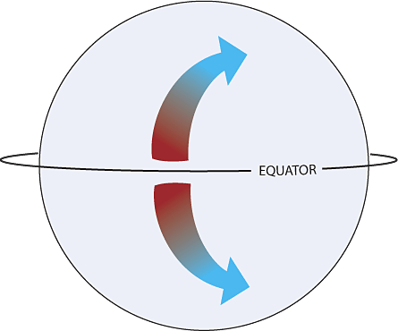

Trade Winds | Prevailing Westerlies | Polar Easterlies
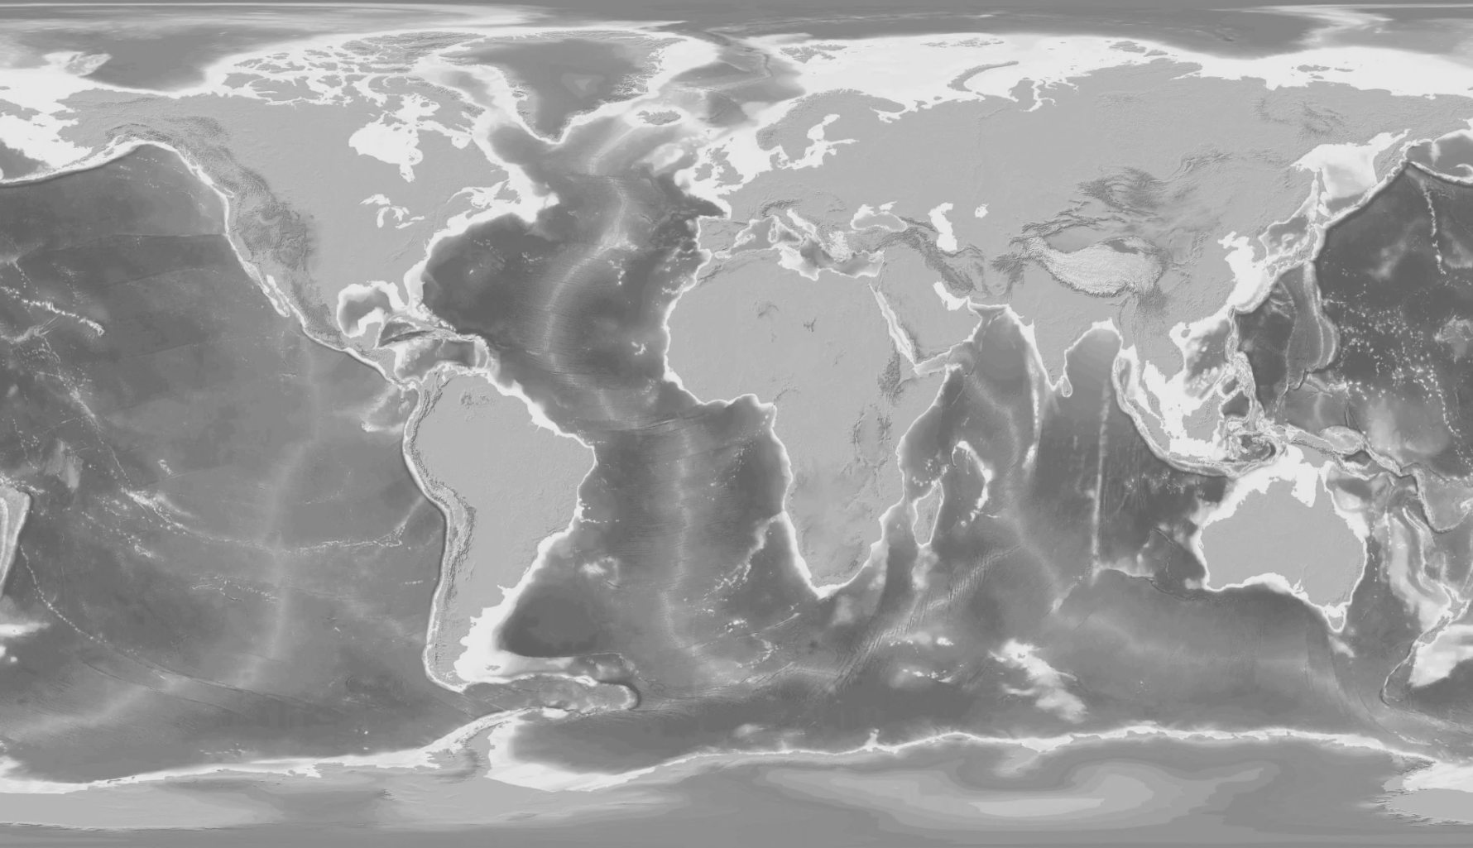
0°
30° N
60° N
90° N
90° S
60° S
30° S

Label the “cells” below:

Modeling the Coriolis Effect
The rotation of the Earth in an easterly direction causes the Coriolis Effect. The Coriolis Effect, in turn, greatly influences the movement of global wind patterns and ocean currents.
Materials:

- Balloon
- Colored Markers

Procedure: Read through steps 2-5 below. Before you do the investigation, predict the path that the pen will trace.
- The ovals below represent your balloon. In steps 2-5 you will rotate your balloon and try to draw a straight line. Predict what your lines will look like by drawing them in the rectangles below. The arrows represent the direction that the balloon will rotate.

- Have one student hold the balloon with one hand at the top and one hand at the bottom.
- That student will rotate the balloon COUNTER-CLOCKWISE slowly, and as nearly as possibly at a constant speed. Try for a rotation rate of about one full turn in five seconds.
- A second will use a marker and slowly draw a STRAIGHT line on the balloon while it is rotating. IMPORTANT: the trick is to try to ignore the motion of the balloon, and move the marker in a straight line.
- Record your results below:

- Repeat steps 2-5 while rotating the balloon in the CLOCKWISE direction.

- How did your predictions (in step 1) compare to your results?

- Compare the sketches you made in steps 5 and 6. Describe any patterns that you observe.

- The COUNTER-CLOCKWISE turning you used as part of step 5 is a model of the way wind moves in the Northern Hemisphere. Why was it necessary to also rotate your model in the CLOCKWISE direction?

- How do you think the shape of the line would vary with the speed of rotation? (What would happen if you made the balloon rotate faster?)

- Test your idea from question #10 and draw your results below:

Our Atmosphere—NOTES
These lines represent our atmosphere from top to bottom. Along the left hand column you will predict where weather takes place, where airplanes fly, where the northern lights happen, and where the peak of Mt. Everest reaches.
Predictions | Actual Answers
Edge of Atmosphere
Surface of Earth

Important Layers
Troposphere:
Ozone:
Greenhouse Effect:
- One important function of our atmosphere is that it keeps our ________________ _________________.
- Certain molecules in the air can __________________ solar radiation (light) and turn it into ______________.
- These molecules include _______________, ________________, _______________. We call these ________________________________________.
- If there are more molecules of greenhouse gases in the air, the atmosphere can ____________________ more _________________.
“Indoor Ozone Stopper” Reading Article Questions

- What claim is the article making?

- List the reasons/evidence that the author uses to back up his claim:

- List 4 new words that you read in this article, and a possible definition based on the way the word was used:
Word | Possible Definition

- Explain where AND why ozone is a “friend to humans” :
- Explain where AND why ozone is a “foe to humans” :

- Draw a picture that shows the structure of an ozone molecule vs. the structure of an oxygen molecule.
Ozone Molecule | Oxygen Molecule

- What discovery led to scientists learning that ozone indoors is being destroyed?

- When ozone and skin oils are mixed together in a laboratory, what is created? Explain if this new molecule is good or bad.
Layers of the Atmosphere
Height (km) |  |  | Magnetosphere
 | 3500  1000  500  100  80 | Thermosphere | Exosphere  Ionosphere
 | 48 | Mesosphere
 | 16 | Stratosphere | Ozonosphere
 | 0 | Troposphere
-100 -80 -60 -40 -20 0 20

Temperature (⁰C)

Fold this column and Glue Down |  |  | Magnetosphere | Fold this column and Glue Down
 | 3500  1000  500  100  80 | Thermosphere | Exosphere  Ionosphere
 | 48 | Mesosphere
 | 16 | Stratosphere | Ozonosphere
 | 0 | Troposphere
Cut Along This Dotted Line Too!
Atmosphere Foldable—Instructions
- Examine the zig zag line on your layers of atmosphere graph. If the temperature of the atmosphere is DECREASING (getting colder) color that part of the line blue. If the temperature of the atmosphere is INCREASING (getting warmer) color that part of the zig zag line red.
- Cut along all dotted lines.
Atmosphere Foldable—Instructions
- Fold on the bold lines of the graph you cut out. You are just folding the small column that is labeled “FOLD THIS COLUMN AND GLUE DOWN.
- Use a glue stick to glue ONLY the small fold onto your graph on page 21 of your packet. It’s as if you are making blue shutters to cover your graph on page 21.
- Cut out each of the boxes below and glue them INSIDE your blue shutters. The objects with pictures will be glued inside the blue FLAPS. The layer descriptions will be glued onto your white graph (INSIDE the shutters)
Cut and Glue These Pieces:
Glue these objects to the INSIDE OF THE FLAPS of your foldable. Put each object in the layer of atmosphere where they belong. |  | Glue these descriptions on the INSIDE MIDDLE of your foldable. Put each description on the layer where it belongs.
Blackbird SR-70  26 km | Weather  0-1 km | Troposphere  - Most weather occurs here where we live  - Convection currents!
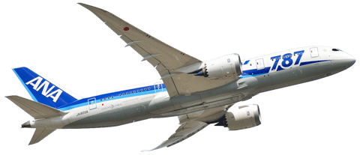  Boeing 787  12 km | 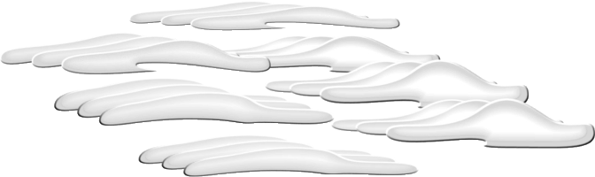  Cirrus Clouds  16 km | Stratosphere  - Contains most of atmosphere’s ozone  - Where jets and manned balloons have gone
Hot Air Balloon  5-7 km | 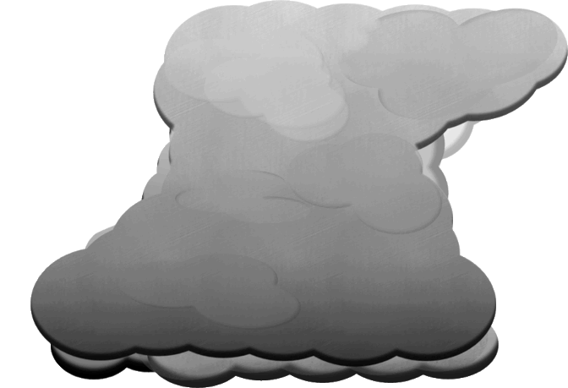  Cumulonimbus  Up to 16 km | Mesosphere  - Protects Earth from meteors  - Coldest region of atmosphere
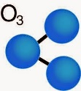  Ozone Molecules  20-30 km | Radio Waves  96-112 km | Thermosphere  - Temperatures get up to 2000 C  - Air molecules are 1 km apart!
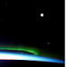  Aurora Borealis  100-250 km | Meteors  48-80 km | Ozonosphere  - Ozone is made of 3 oxygen atoms  - Protects the surface from Solar UV rays  - Humans can contribute to “holes” in the ozone
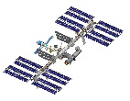  International Space Station  300 km | 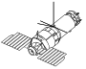  Unmanned Spacecraft  3000 km | Ionosphere  - Lower part of the thermosphere  - Radio waves bounce back to Earth’s surface
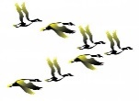  Flock of Geese  6-7 km |  | Exosphere  - Upper part of thermosphere  - Artificial satellites orbit here
Magnetosphere
- Earth’s magnetic field
- Causes Aurora Borealis (Northern Lights)

